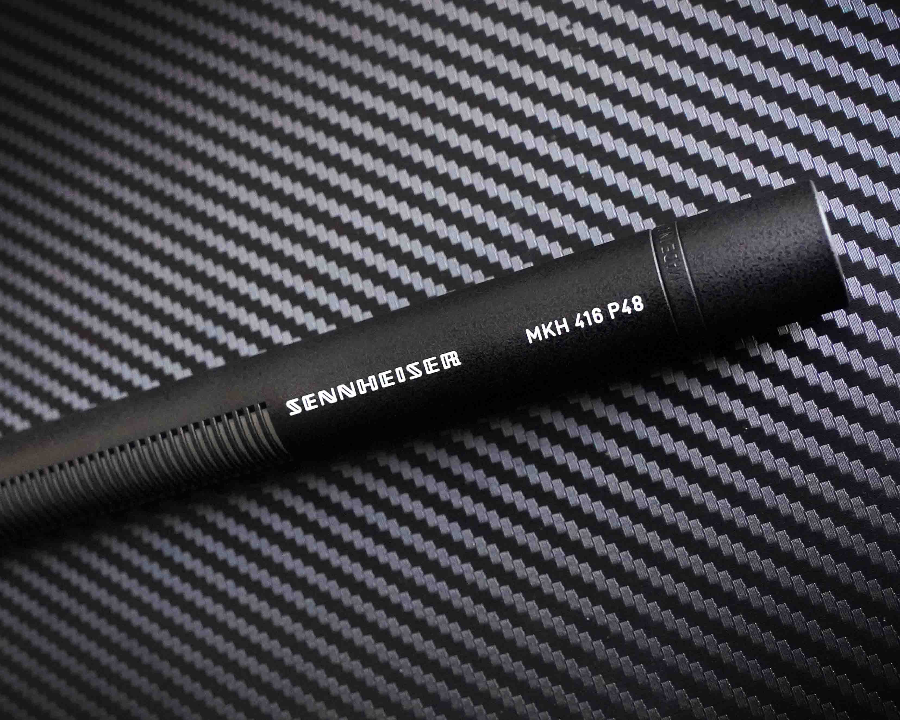The Sennheiser MKH 416 shotgun microphone is 50
20% anniversary discount on the all-time classic in April

Wedemark, March 2025 – One of Sennheiser’s most revered microphones, the MKH 416 P48 shotgun microphone, celebrates its golden jubilee this year! For 50 years, the MKH 416 has accompanied broadcasters, filmmakers, voice-over artists, and content creators; it has been used in studios and in the field. Mounted onto a boom pole, a stand or a camera, its job has been to stay outside the camera angle while gracefully capturing sound with clarity and impact. To celebrate its golden jubilee, this classic mic is offered with a 20% anniversary discount at participating Sennheiser dealers and – where available – the company’s website in April.

Time travelling to the 1970s
The name of Manfred Hibbing is firmly linked with this milestone product. When the young engineer joined Sennheiser, his first task was to design the MKH 416 P48 on the basis of the MKH 415 T. The MKH 416 was to be Sennheiser’s first phantom-powered (P48) shotgun microphone, while all previous models were AB-powered. In those days, AB powering was preferred in broadcast situations because of its resistance to ripple voltages, but phantom powering had become established in the studio.

50 years old but always up to date
Hibbing’s involvement was a stroke of luck for the MKH 416 RF condenser microphone, as he possessed ample expertise both in electroacoustics and in RF technology. In an interview in 2023, he said that optimising the interaction between the electroacoustic transducer and the electronic circuit had been his favourite task in designing the 416.

The long lifespan of the MKH 416 P48 fills the engineer with pride: “During all this time, the design of the MKH 416 was only revised in two instances: one was to make it suitable for SMD mounting, and the other to update it for a more advanced transducer technology.”

 | Manfred Hibbing with the MKH 416. The photo was taken in 2023

A standard in the studio and in the field – but why exactly?
One reason is that the MKH 416 operates on the RF condenser principle. In this context, RF (radio frequency) has nothing to do with wireless, but rather refers to the high-frequency voltage at the capsule and the associated electronics in the microphone. The huge advantage of this design is that it makes the condenser microphone resistant to humidity. Unlike “standard” condenser microphones, RF condenser models can be used outdoors, in hot and humid or cold and misty weather. MKH microphones have reliably recorded audio in a wide variety of challenging locations, from deserts, to the Arctic, to rain forests.

RF condenser microphone used in outdoor broadcasting | 

Another reason for the success of the MKH 416 is in its excellent directivity, which is the result of the acoustic interference principle on which it operates. The actual microphone capsule is combined with a so-called interference tube in front of it. This tube has regularly arranged slots, which are covered with fabric that has a certain acoustic impedance, and prevents reflections and standing waves inside the tube. If sound arrives directly from the front, the interference tube has no effect at all. But when sound enters the tube from the sides, it passes through different holes. This results in different path lengths to the transducer and thus different time delays. Depending on the angle of sound incidence, the sound components more or less cancel each other out. This effect increases at higher frequencies: Here, the microphone essentially picks up the sound coming from the front. This is particularly important for speech intelligibility as the decisive speech formants are recorded with less lateral interference at high frequencies than with standard microphones.

The MKH 416 offers a perfect mix of directivity and climate-proof design | 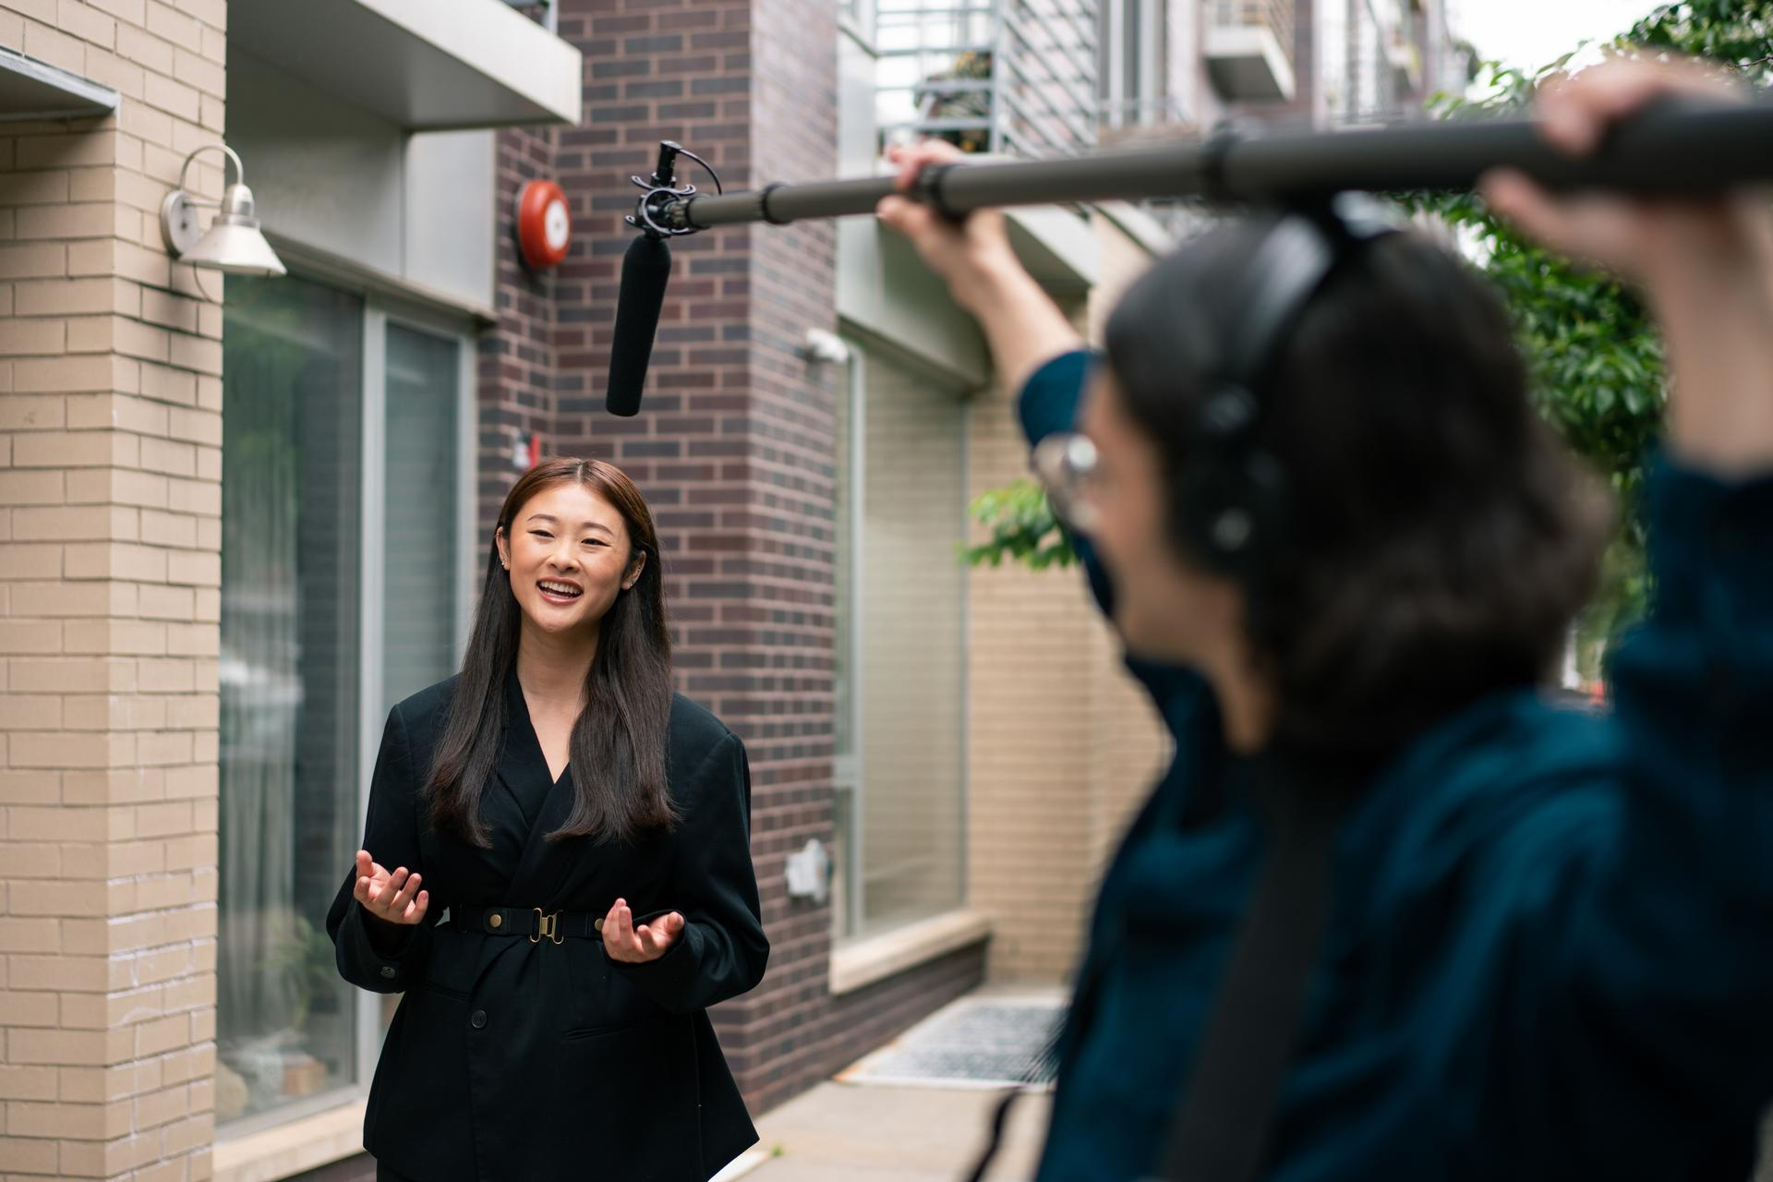

The longer the shotgun, the more this interference principle extends to lower frequencies. Unfortunately, the longer length also makes the microphone more difficult to handle. The MKH 416 is certainly so popular because, despite its short length, it offers an effective directionality. How this particular length came about is its own story, and that takes us back to its predecessor, the MKH 415 T…

The hacksaw and the microphone
In 1970, the newly designed MKH 415 shotgun microphone was the pride and joy of the Sennheiser development engineers. It was less sensitive to wind and pop noise, had greater resistance to handling noise, and excellent directivity. With the new microphone in his briefcase, an enthusiastic Dr. Griese, technical manager at Sennheiser, went off to visit radio and TV broadcasters. The customers showed a great deal of interest in the new shotgun microphone – but couldn’t resist picking at it. They complained that the shotgun effect was so strong that you had to keep moving the microphone to follow the speaker around.

Dr. Griese, then Sennheiser’s Technical Manager, was an engineering genius with a sense of humour | 

Dr. Griese listened to the comments for a while and then asked for a hacksaw. “How much directivity would you like?” he asked the amazed observers. And without batting an eyelid he proceeded to saw off a section of the microphone tube. The customers were stunned. Dr. Griese then tried out the shortened microphone once again and, to everyone’s amazement, it was perfect! From then on, the MKH 415 – and thus also the MKH 416 which followed its design – were highly successful as the preferred microphone for vocalists, film teams and reporters, with the specialist media being equally impressed by the “unusually short length” (Funkschau) of the shotgun mic.

Conclusion
“The MKH 416 remains a star of our shotgun microphones, even though we have launched younger models long since,” concludes product manager Kai Lange. “It’s just great to have such a legend in the portfolio, a versatile, long-life, high-performance microphone. The MKH 416 is a mic where everything was perfect from the start.”

------

A short history of Sennheiser’s shotgun and RF condenser microphones
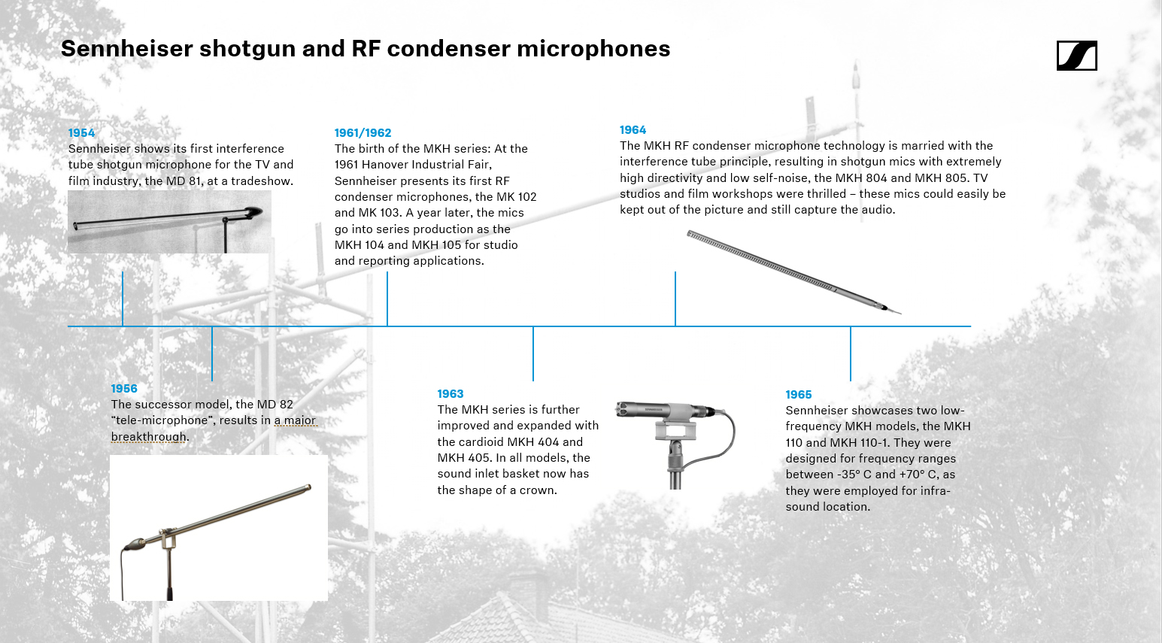

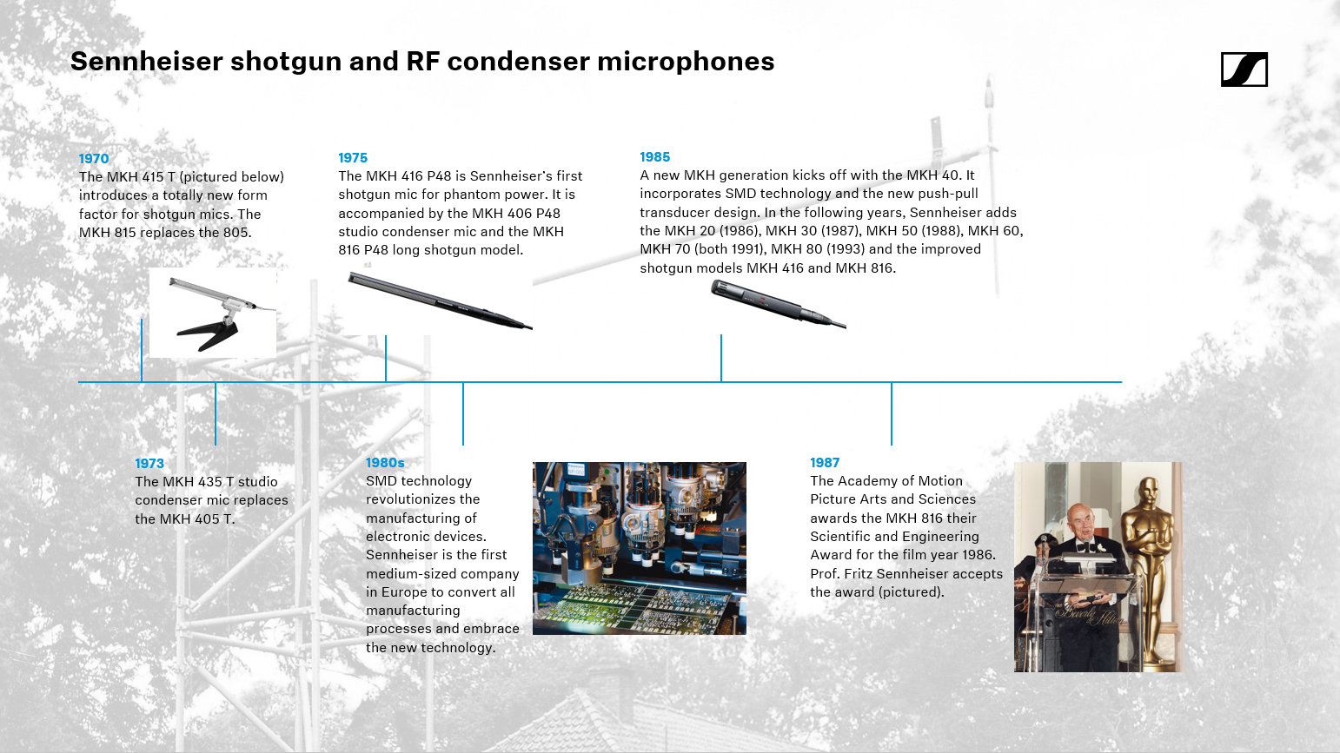

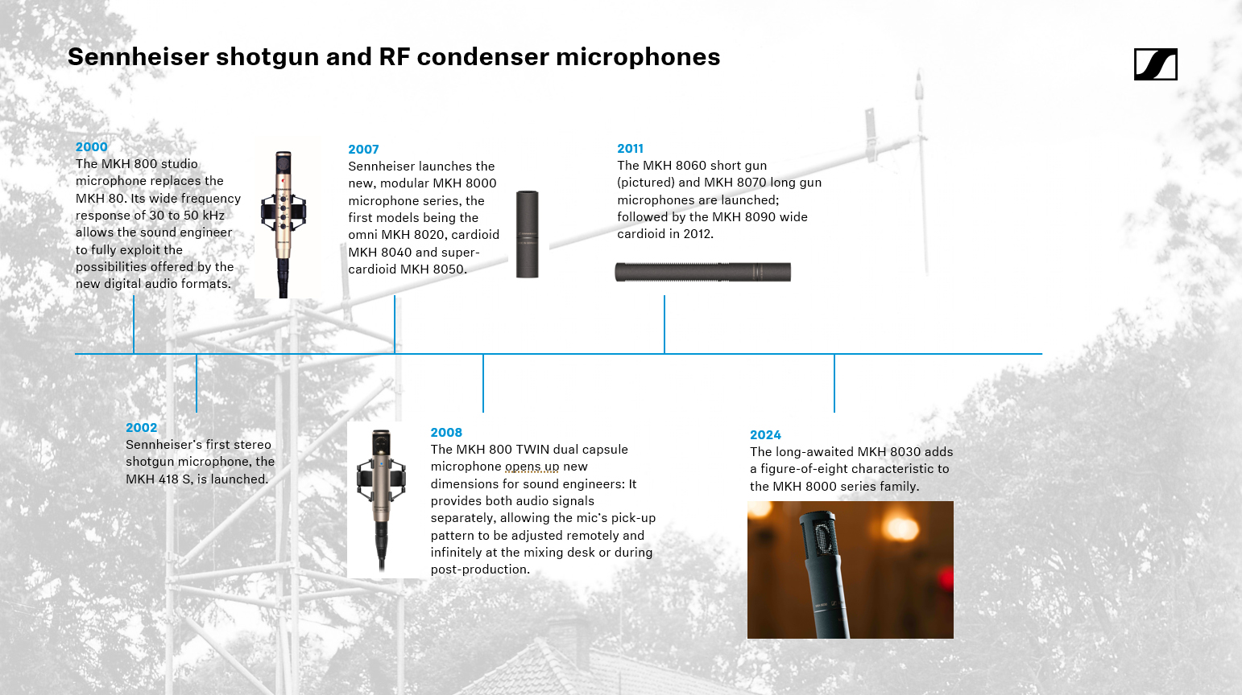

(Ends)

The high-resolution images accompanying this media release can be downloaded here, the images of the timeline here.

About the Sennheiser brand
We live and breathe audio. We are driven by the passion to create audio solutions that make a difference. Building the future of audio and bringing remarkable sound experiences to our customers – this is what the Sennheiser brand has represented for more than 75 years. While professional audio solutions such as microphones, meeting solutions, streaming technologies and monitoring systems are part of the business of Sennheiser electronic SE & Co. KG, the business with consumer devices such as headphones, soundbars and speech-enhanced hearables is operated by Sonova Holding AG under the license of Sennheiser.

www.sennheiser.com
www.sennheiser-hearing.com

Global Pro Audio Press Contact
Stephanie Schmidt
stephanie.schmidt@sennheiser.com
+49 (5130) 600–1275

Local Press Contacts
Daniella Kohan
daniella.kohan@sennheiser.com
+1 860 598-7420

Kirsten Spruch
kirsten.spruch@sennheiser.com
+1 860 598-7484

Peter Schuyler
peter@ingearpr.com.com
+1 917 496-8970

